Name : Vũ Đức Tùng
IRN: 2331300132
Course : CSE 203
Lab 1
Problem 1:
- Entities and attributes:
- Doctor ( doctor_code , full_name, date_ of_employment, specialty )
- Patient ( patient _ code , full _ name, date _of _ birth, place )
- Record (treatment_date , treatment_duration, treatment _result)
- Relation:
- Doctor – Patient: Admit ( 1 : n)
- Doctor – Patient: Treat (n : n)
- Doctor – Record: (1 : n )
- Patient – Record : (1: n )
- ERD

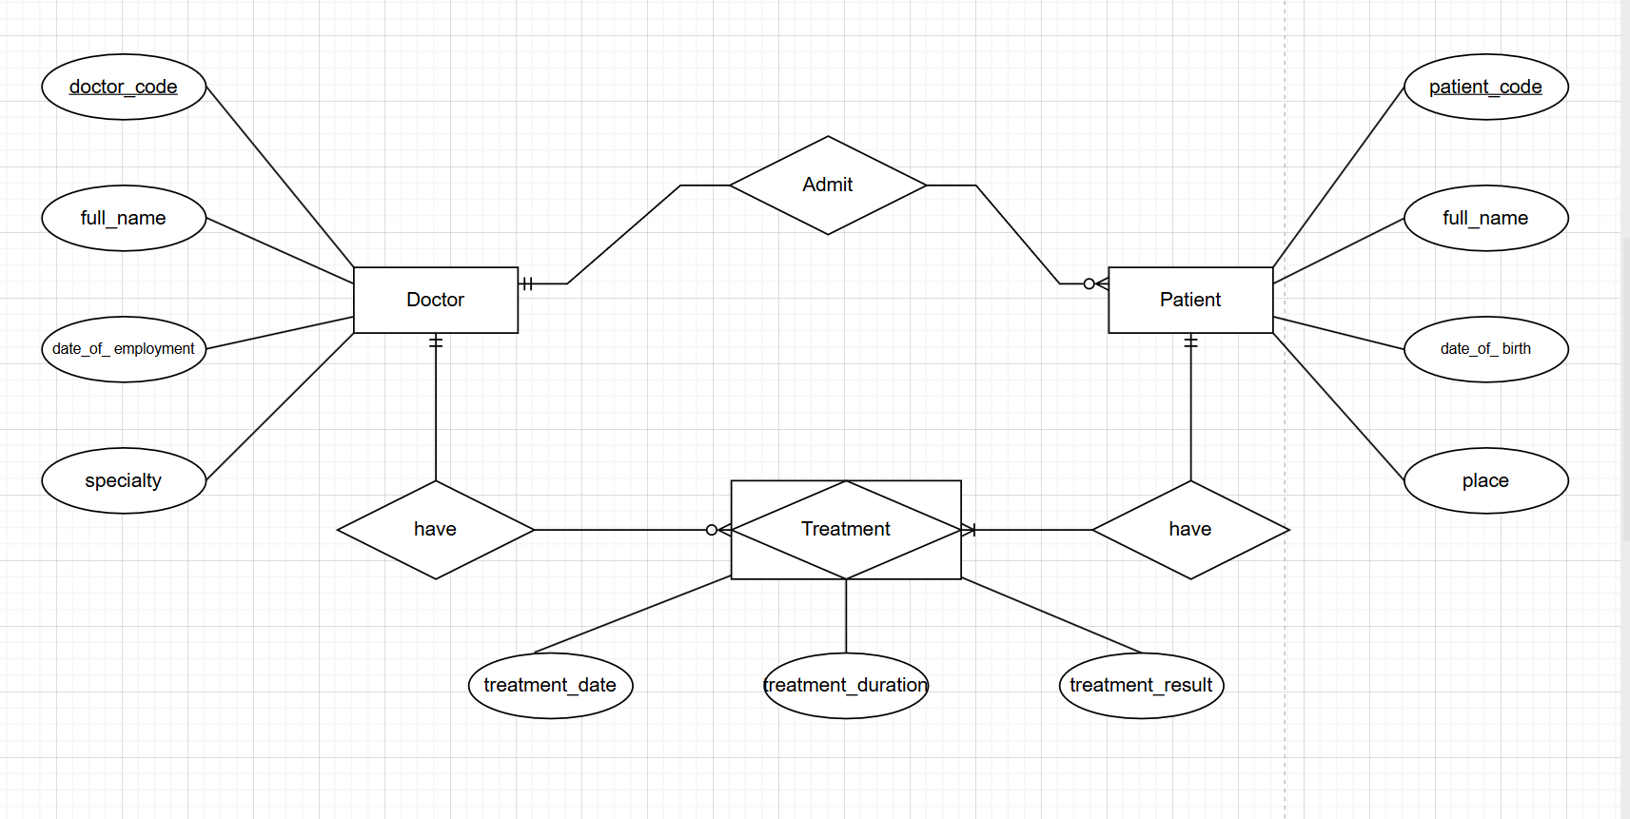

Problem 2:
- Entities and attributes:
- faculty ( faculty_code, faculty_name)
- department ( department_code , department_name)
- class ( class_code, class_name, numbers_of_students)
- student ( student_id, full_name, date_of_birth , gender , address)
- subject ( subject_code , subject_name, number_of_credits)
- libary_card ( card_number, issue_date, expiration_date)
- exam_result ( exam_score , gradutation _score)
- Relation:
- faculty – department : ( 1 : n )
- department – class : ( 1: n )
- student – class : (n :1 )
- student - subject : ( m: n )
- subject – exam_result : (1 : 1)
- student – library_card (1 : 1)
- Weak entity:
- Weak entity : library_card
- Associative entity : exam results
- ERD
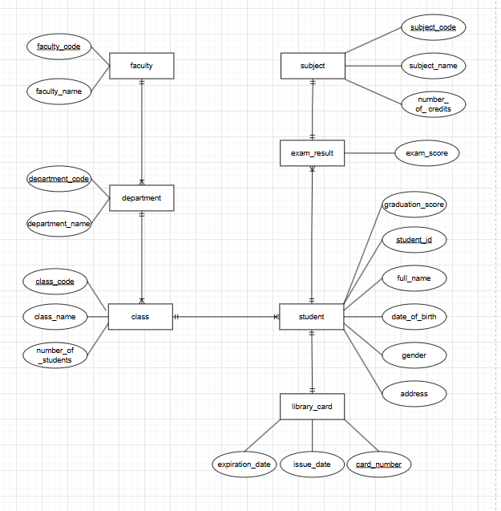
Problem 3
- Entity and attribute
- room ( room_code, room_name, floor , daily_rate, weekly_rate)
- floor ( floor_code, floor_name)
- guest ( guest_identity, full_name, phone_number)
- invoice( invoice_code, guest_information, room_used, arrial_date, departure_date, room_charge, total_service_charge, final_total)
- service ( service_code , service_name , unit_price)
- service_record ( invoice_code , service_code , quantity)

- Relation
- floor – room : have ( 1:n)
- guest - invoice : have (1 : n)
- room - invoice : have (1:n)
- guest – service : (1:n)
- service – service_record : have ( 1 : n)
- invoice – service_record : use ( 1 :n)

- Weak eintity
- service_record.

- ERD
